15.82: a)and so the instantaneous power is
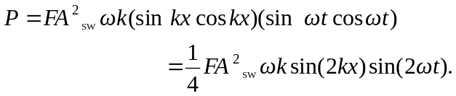
b) The average value of P is proportional to the average value of 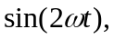 and the average of the sine function is zero; 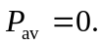 c) The waveform is the solid line, and the power is the dashed line. At time 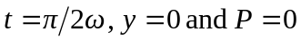 and the graphs coincide. d) When the standing wave is at its maximum displacement at all points, all of the energy is potential, and is concentrated at the places where the slope is steepest (the nodes). When the standing wave has zero displacement, all of the energy is kinetic, concentrated where the particles are moving the fastest (the antinodes). Thus, the energy must be transferred from the nodes to the antinodes, and back again, twice in each cycle. Note that 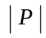is greatest midway between adjacent nodes and antinodes, and that P vanishes at the nodes and antinodes.

